Before Lock
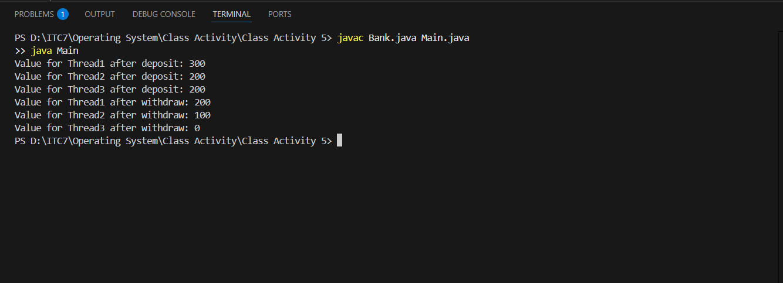

After Lock
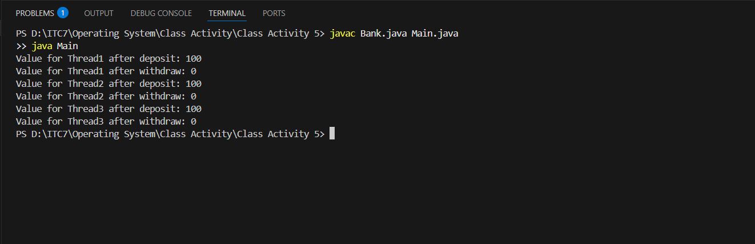

https://github.com/Chumdararith-LOU/Activity-Synchronization-I-Mutex-Lock.git

